UNDP and GEF/SGP Botswana Support Grantees to attend the Global National Adaptation Expo (NAP Expo) in Botswana

The Government of Botswana through the Ministry of Environment hosted the Global National Adaptation Plan (NAP) Expo from 22nd to 26th August 2022 under the theme “Transformation to Adapt”. The NAP Expo is an annual outreach event organized by the Least Developed Countries Expert Group (LEG) under the UNFCCC, in collaboration with various bodies and organizations, to promote an exchange of experiences and foster partnerships between a wide range of actors and stakeholders on how to advance National Adaptation Plans (NAPs).

With the objectives of facilitating the interaction between country NAP teams and providers of support and other relevant organizations, enhancing access to financing for NAPs, and creating an interactive global forum on NAPs for countries to share experiences, best practices, and lessons learned, the Expo brought more than 400 stakeholders from across the World to discuss and share notes on the implementation of the NAPs. In Addressing the delegates, His Excellency the President of the Republic of Botswana Dr. Mokgweetsi Eric Keabetswe Masisi when addressing the High-level meeting segment of the National Adaptation Plan Expo said that climate change has already resulted in substantial financial loss and livelihoods alteration. He indicated that adaptation was therefore not a choice but development and socio-economic imperative.
The Global Environmental Facility Small Grants Programme (GEF-SGP) Botswana Country Office in partnership with UNDP Botswana Country Office supported the participation of three GEF-SGP Grantees to showcase what they are doing in transforming the Communities to adapt to Climate Change.
One of the grantees, Green Habitat Botswana, showcased vermicomposting initiative to produce green manure from food leftovers and other organic waste collected from schools, hotels, restaurants, homesteads and other places.
Green Habitat Botswana explained that they realized that organic waste at landfills contributes to the emission of greenhouse gases like methane. In addition to combating climate change, Green Habitat Botswana is capacitating communities on the value of compost fertilizers in climate-smart agricultural methods to enhance food security, improve human livelihoods and drive towards greening the environment.
The other Grantee, Botswana Climate Change Network showcased the hydroponics technology as one of the climate-smart agriculture practices that can be adopted in the wake of increased temperatures and unpredictable weather patterns perpetuated by unreliable and below-average rainfall leading to low agricultural productivity and a serious threat to our food security. The Grantee has set up a hydroponics technology project in Gweta village, with a target of training villagers and farmers from within and around the village on the technology. The project intends to integrate communities into innovative climate-smart agroecology, in an effort to assist them to adapt to the impacts of climate change. The project has noted that the integration of local farmers and all relevant stakeholders into climate-smart innovative agroecology techniques and overall climate change initiatives can go a long way in ensuring that communities are able to build resilience to withstand the challenges brought by the negative impacts of climate change. Hydroponics is a soilless technique for growing plants in a water-soluble mixture. Through this technique, vegetables can be grown in any condition, especially where conventional farming is not suitable.
The third beneficiary of the Global Environmental Facility Small Grants Programme (GEF/SGP) at the event, “Matute a Mongongo” Cooperative Society also showcased the support they received from the UNDP Country Office on the extraction of oil from the nut of the mongongo tree. The oil is of high value and can be used for cooking and for the preparation of cosmetics. The mongongo plant is a natural resource found within the areas that communities in North-Western Botswana can access and utilize to improve their livelihoods. The Grantee also with the support will develop a nursery where propagation of the mongongo trees will take place to ensure sustainability and availability of the mongongo nut.

Photos
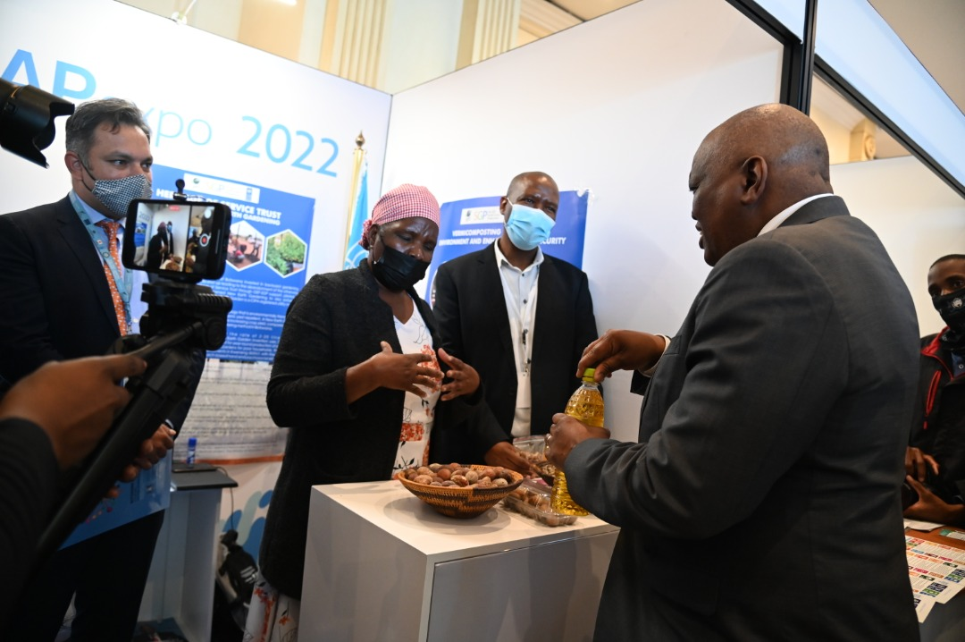

Photo 1:
Ms Divuyu Ndara explaining production of Mongongo oil to His Excellency the President of Botswana Dr M.E.K. Masisi during the NAP Expo.

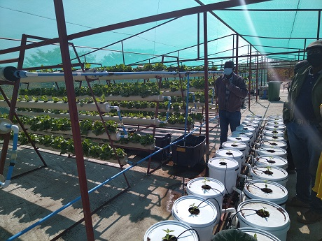

Photo 2:
Botswana Climate Change Network (BCCN) Hydroponics System in Gweta Village

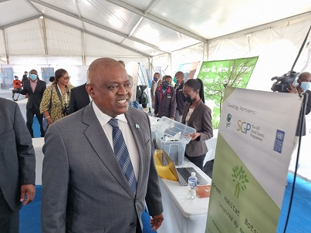

Photo 3: His Excellency the President Dr M.E.K. Masisi viewing the Green Habitat Botswana Stall during the NAP Expo.

